Project

1

Indian institute of technology

Software engineering project

Octal To Decimal Convertor Guide

Software engineering project

Octal To Decimal Convertor Guide

Table of Contents

* Buttons and Uses………………………………………………………………1
* Screenshots…………………………………………………………………….2
* Input Format…………………………………………………………………...8

User Interface

# Convert

This button is for conversion of octal to decimal number. It leads to a conversion only if correct input is given. Same output is obtained by pressing return in inputbox

# Reset

Clears input and output boxes.

# File Input

Choose an input file containing the octal number to be converted to an decimal.

# File Output

Specify file to write result to .

# Exit

Exits the application

# Show Visualisation (checkbox)

Enable or disable visualization.

# Octal (input field)

Enter the number to be converted in this field

# Decimal (output field)

The converted decimal number is displayed in this field. The result can be copied.

# 

# 

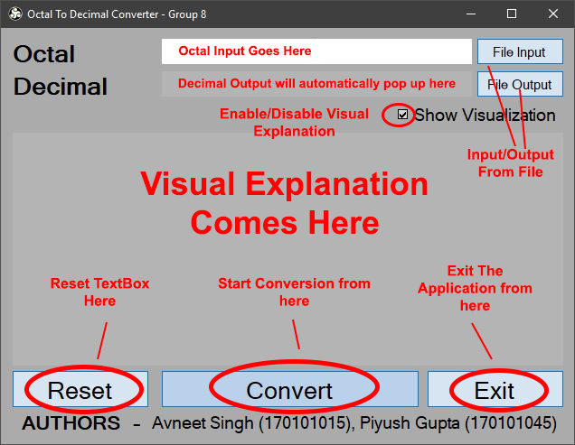

All the controls are mentioned in the picture above

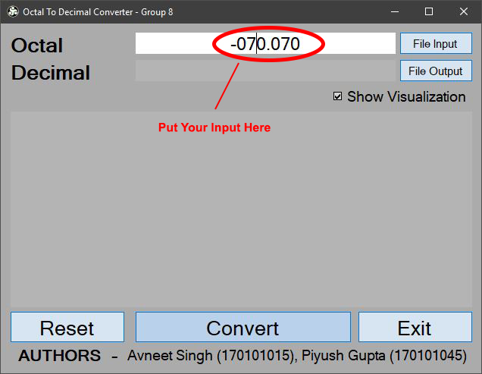

To provide input, user can use both textbox as well as file input. **File Contents are trimmed from both sides**, but still the number needs to be in correct syntax or you will be presented with an error.

Numbers can be positive/negative as well as with fractional parts

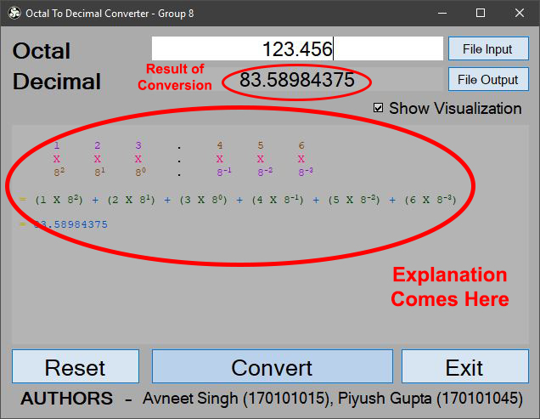

After you have input your number, click on convert or just press Enter to start conversion.

To provide input from file, just click on "File Input" button and select your file.

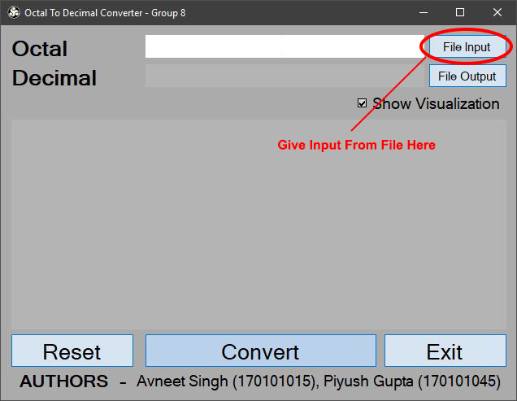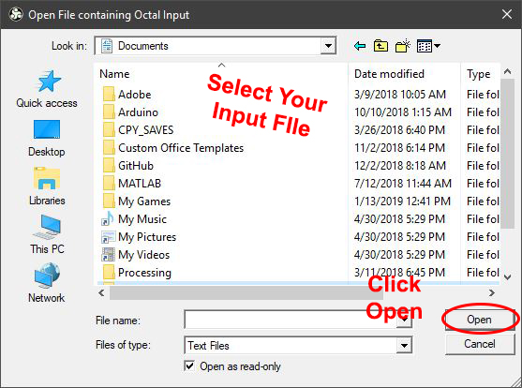

Content of your file will be loaded into Input TextBox and Other textbox will show you the result.

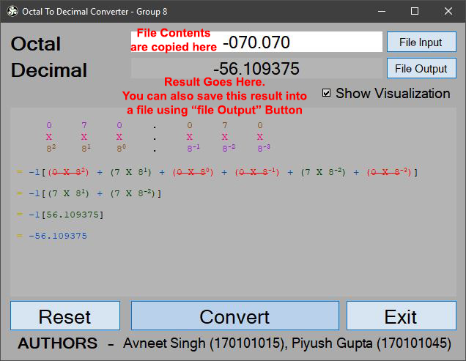

Similarly, you can also save result into a text file. Just click "File Output" button , select location of storage, provide a name for the file and click save

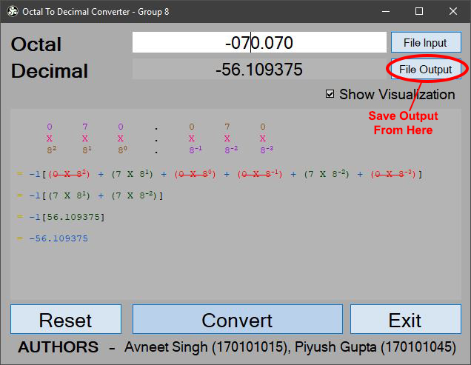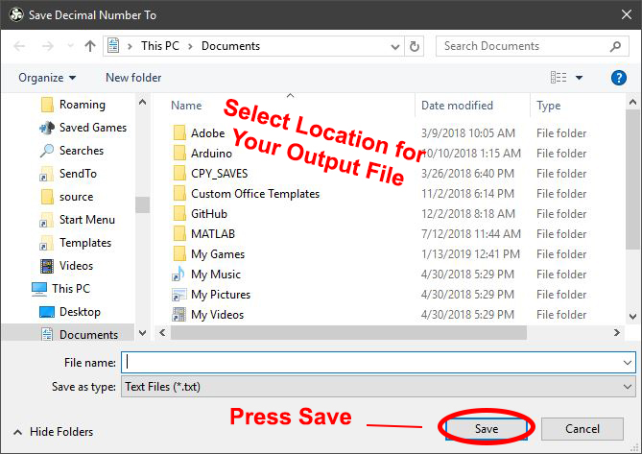

Input Format

* ALL DIGITS SHOULD BE BETWEEN 0 AND 7
* IT MAY INCLUDE A SIGN IN THE BEGINNING
* IT MAY INCLUDE A DECMIAL POINT
* INCLUSION OF COMMAS “,” NOT ALLOWED
* NO DIGIITS BEFORE DECIMAL POINT ALLOWED
* NO DIGITS AFTER DECIMAL POINT NOT ALLOWED